PROGRAM TITLE

finance operations

PROCESS TITLE

Billing, Collection and Cash Handling

1. SCOPE

This policies and procedures manual establishes policies, systems, procedures and controls on the billing, collection, and cash handling. All duties and responsibilities stated in this manual are not exclusive to the personnel’s designated responsibilities in this process title.

1. OBJECTIVES

* To ensure that customers are properly billed.
* To make sure that collections are properly summarized and recorded.
* To ensure that assets are properly handled and secured.
* To clearly define the duties and responsibilities of all personnel involved in this process title.

1. PERSONNEL INVOLVED

* 1. Billing Staff

* + 1. Receives documents (i.e. out-turn report, etc.) from Operations Department.
    2. Prepares computation and Statement of Account (SOA) based on the documents obtained from the Operations Department.
    3. Forwards the following:
* SOA and its corresponding supporting documents (i.e. computation, out-turn report, etc.) to Finance Manager for approval.
* Approved SOA with appropriate attachments to Bookkeeper, if applicable, for recording and filing.
* Photocopy of approved SOA to President for monitoring.
  + 1. Sends/Asks its Representative to send SOA with appropriate attachments, if applicable, to customers.
    2. Scans SOA and its corresponding attachments and files scanned copy accordingly.
    3. Files hard copy of SOA accordingly.
    4. Updates SOA monitoring.
  1. Cashier
     1. Receives:
* Collections (i.e. cash, check, bank transfer, etc.)
* Machine validated deposit slip from the Collector
  + 1. If mode of collection is:
* Cash / Check – issues official receipt
* Postdated Check – issues Acknowledgment Receipt (AR) and updates postdated checks monitoring.
* Bank Deposit/Transfer – issues official receipt after:
* verification of deposit/transfer with the Bank / Payor; and
* obtaining machine validated deposit slip / payment confirmation
  + 1. Prepares:
* Deposit slip for the deposit of collections (i.e. cash, check)
* Daily Cash and Check Received Report every end of the day or after office hour
  + 1. Requests the Collector to deposit the collection.
    2. Forwards:
* DCCRR, cash and supporting documents (i.e. official receipt, etc.) to Finance Manager for approval
* Approved DCCRR with photocopied supporting documents to accounting department for recording
* Approved DCCRR to billing department for updating of SOA monitoring
  + 1. Files DCCRR with supporting documents accordingly.
  1. Finance Manager
     1. Receives:
* SOA and supporting documents (i.e. computation, out-turn report, etc.) from billing staff
* DCCRR, cash and supporting documents (i.e. official receipts, etc.) from cashier
  + 1. Forwards duly approved SOA with supporting documents to billing staff for sending to customers.
    2. Conducts cash count in the presence of Cashier. Subsequently, verifies DCCRR.
  1. Collector
     1. Collects receivable accounts and may issue official / acknowledgment receipts when given the authority to do so.
     2. Signs the Collection for Deposit Logbook as proof of receipt of cash received from cashier for deposit.
     3. Deposits collection to the bank, obtains machine validated deposit slips from the bank, forwards the same to the Cashier and signs the Collection for Deposit Logbook.
  2. Bookkeeper
     1. Receives the following:
* Approved DCCRR with photocopied supporting documents from Cahier.
* Approved SOA with appropriate supporting documents, if applicable, from Billing Staff.
  + 1. Records appropriate journal entries based on the official receipts and approved SOA.
  1. President
     1. Receives photocopy of approved SOA for monitoring and files accordingly.

1. ACCOUNTS

| **Account Code** | **Account Title** | **Account Description** |
| --- | --- | --- |
|  |  |  |
| 000-00-00-000-0000-1101-1040 | Cash on hand | Cash and Cash Equivalents |
| 000-00-00-000-0000-1101-1050 | Cash In Bank | Cash and Cash Equivalents |
| 000-00-00-000-0000-1102-1150 | Trade receivables | Receivables |
| 000-00-00-000-0000-1110-1501 | Creditable Withholding Tax | Other Current Assets |
| 000-00-00-000-0000-2121-2040 | Output Tax | Other Current Liabilities |
| 000-00-00-000-0000-2121-2041 | Output Tax-Uncollected | Other Current Liabilities |
| 000-00-00-000-0000-4141-4000 | Integrated Cargo Handling Services | Revenue |
| 000-00-00-000-0000-4142-4050 | Voyage Charter | Revenue |
| 000-00-00-000-0000-4143-4100 | Time Charter | Revenue |
| 000-00-00-000-0000-4144-4150 | Towing Services | Revenue |
| 000-00-00-000-0000-4145-4200 | In-warehouse Handling | Revenue |
| 000-00-00-000-0000-4146-4250 | Trucking Services | Revenue |
| 000-00-00-000-0000-4147-4300 | Lighterage | Revenue |
| 000-00-00-000-0000-4148-4350 | Merchandise Sales | Revenue |
| 000-00-00-000-0000-4155-4900 | Other Income - Interest | Other Income |
| 000-00-00-000-0000-4155-4901 | Other Income - Rental | Other Income |
| 000-00-00-000-0000-4155-4902 | Other Income - Scrap Items | Other Income |
| 000-00-00-000-0000-4155-4903 | Other Income - Sale of product damages | Other Income |
| 000-00-00-000-0000-4155-4904 | Other Income - Used Oil | Other Income |
| 000-00-00-000-0000-4155-4905 | Other Income - Miscellaneous | Other Income |
| 000-00-00-000-0000-4155-4906 | Other Income - Sale of Assets | Other Income |
|  |  |  |

1. JOURNAL ENTRIES
   1. Establishment of Revenue and Receivable Accounts

|  |  |  |  |  |  |
| --- | --- | --- | --- | --- | --- |
| **Account Code** |  | **Account Title** | | **Dr.** | **Cr.** |
| 000-00-00-000-0000-1102-1150 |  | Trade Receivables | | xx |  |
| xxx-xx-xx-xxx-xxxx-xxxx-xxxx |  |  | Revenue* |  | xx |
| 000-00-00-000-0000-2121-2041 |  |  | Output Tax-Uncollected |  | xx |
|  |  | *To set-up revenue and receivable accounts* | | | |

*\*Appropriate revenue account should be used for every type of services.*

* 1. Collection of Receivable Accounts

1. Cash Collection

|  |  |  |  |  |  |
| --- | --- | --- | --- | --- | --- |
| **Account Code** |  | **Account Title** | | **Dr.** | **Cr.** |
| 000-00-00-000-0000-1101-1040 |  | Cash on Hand | | xx |  |
| 000-00-00-000-0000-1110-1501 |  | Creditable Withholding Tax | | xx |  |
| 000-00-00-000-0000-1102-1150 |  |  | Trade Receivables |  | xx |
|  |  | *To record cash collection of receivable accounts* | | | |

1. Check or Bank Deposit/Transfer Collection

|  |  |  |  |  |  |
| --- | --- | --- | --- | --- | --- |
| **Account Code** |  | **Account Title** | | **Dr.** | **Cr.** |
| 000-00-00-000-0000-1101-1050 |  | Cash In Bank | | xx |  |
| 000-00-00-000-0000-1110-1501 |  | Creditable Withholding Tax | | xx |  |
| 000-00-00-000-0000-1102-1150 |  |  | Trade Receivables |  | xx |
|  |  | *To record collection of receivable accounts* | | | |

1. Reversal of Output Tax-Uncollected to Output Tax Account upon collection

|  |  |  |  |  |  |
| --- | --- | --- | --- | --- | --- |
| **Account Code** |  | **Account Title** | | **Dr.** | **Cr.** |
| 000-00-00-000-0000-2121-2041 |  | Output Tax-Uncollected | | xx |  |
| 000-00-00-000-0000-2121-2040 |  |  | Output Tax |  | xx |
|  |  | *To record output tax based on collection* | | | |

* 1. Adjustment for Deposit of Cash Collection *(refer* ***B.1****, page 5)*

|  |  |  |  |  |  |
| --- | --- | --- | --- | --- | --- |
| **Account Code** |  | **Account Title** | | **Dr.** | **Cr.** |
| 000-00-00-000-0000-1101-1050 |  | Cash In Bank | | xx |  |
| 000-00-00-000-0000-1101-1040 |  |  | Cash on Hand |  | xx |
|  |  | *To record deposit of cash collections* | | | |

1. POLICIES
   1. **General**
      1. All documents (i.e. out-turn report, etc.) related to preparation of Statement of Account (SOA) should be duly signed by designated signatories.
      2. Only approved SOA are sent to customers.
      3. Official receipts, acknowledgment receipts, statement of accounts, and other accountable forms should be pre-numbered and registered with the BIR, if applicable.
      4. Proper segregation of duties should be considered and implemented. As a minimum requirement, “approval”, “custody”, and “recording” functions should be segregated. Thus, management should make sure that an employee is not allowed to perform these functions all on his own.
   2. **Billing**
      1. Billing documents (i.e. SOA, computation) should be prepared based on the duly signed supporting documents (i.e. out-turn report, etc.) from the Operations Department.
      2. Any discrepancies with the supporting documents (i.e. out-turn report, etc.) received from the Operations Department should be verified immediately to the appropriate personnel.
      3. The approved SOA with supporting documents (i.e. computation, out-turn report, etc.) should be duly conformed by the customer as a proof of receipt and confirmation of details (i.e. amount, terms, etc.) of the SOA.
   3. **Collection**
      1. All collections should be supported with receipts (i.e. official receipts or acknowledgment receipts).
      2. All collections should be deposited intact on the same day or the next banking day. Any disbursement from the collections is STRICTLY PROHIBITED.
      3. Acknowledgment receipt (AR) is issued in case of postdated checks collection. The cashier will monitor the due dates of the checks and an official receipt is issued upon due date or clearing of check upon deposit.
      4. The cashier should see to it that collections made through collecting agents/collectors are accounted for and deposited intact.
      5. Mode and manner of collections are as follows:

|  |  |  |
| --- | --- | --- |
| **Mode of Collection** | **Document Issued** | **Manner of Collection** |
| Cash / On-date Check | Official Receipt | Through cashier or collecting agent/collector |
| Postdated Check | Acknowledgment Receipt | Through cashier or collecting agent/collector |
| Bank transfer / deposit | Official Receipt | Through bank. The cashier will monitor collections made through Company’s bank account. Customer or depositor is required to forward to the Company’s office proof of deposit (i.e. deposit slip) and will be verified by the cashier before issuance of OR. |

* 1. **Cash Handling**
     1. The cashier should only be the one handling the collections until deposited to the bank.
     2. In cases when the cashier will not be available (i.e. on leave), the collection process may be performed by a designated qualified alternative cashier taking into consideration the proper segregation of duties. Subsequently, a cash count will be conducted in the presence of the Finance Manager or representatives from the accounting department prior to take-over to establish accountability. The result of the cash count shall be filed accordingly.
     3. Upon return of the cashier, the collection process should start in the same manner discussed above *(refer to* ***section VI.D.2****)*.
     4. Safes and other facilities should be provided to insure protection of cash and unused accountable forms.
     5. The collection should not be mixed with other funds (i.e. revolving fund, etc.).
     6. Exchange of cash should not be done after the establishment of DCCRR.
     7. Surprise cash count shall be made.
     8. The collecting officer, as well as employees handling cash should be adequately bonded.
     9. Subject to recommendation of the finance head/risk compliance head and approval of the senior management, cash on hand should be insured.
  2. **Recording and Documentation**
     1. Set-up of receivable account should be based on duly approved SOA with proper attachments (i.e. computation, out-turn report, etc.).
     2. Collections should be recorded based on the official receipts.
     3. SOAs with its corresponding supporting documents should be filed accordingly.
     4. Cancellation of the SOA must be duly approved by authorized officer. Subsequently, all copies of SOA should be properly marked “CANCELLED”.
  3. **Monitoring**
     1. The DCCRR should be prepared at the end of the day. Supporting documents (i.e. official receipts, etc.) should be attached accordingly.
     2. The “Collections for Deposit Logbook” should be duly filled-out and signed by the collector or representative before deposit of collections is made to secure accountability of the asset (i.e. cash).
     3. The SOA monitoring should be monitored daily to lessen aged accounts.
     4. Postdated checks are monitored daily to determine checks due for deposit.
     5. The customer’s information (i.e. name, address, TIN, rate per service, etc.) should be maintained and updated regularly.
     6. For collections made through collecting agents/collectors, a transmittal report should be prepared upon turn-over of funds to the cashier. This will summarize all collections made indicating (at a minimum) the date, payor, amount collected, and reference OR/AR number.
     7. Reconciliation of banking transactions should be done by persons other than those responsible for the handling of cash receipts and deposits.
     8. Monthly reports of accountability for accountable forms should be prepared and submitted by all accountable officers.

1. PROCEDURES

| Billing and Collection | | | |
| --- | --- | --- | --- |
| Step No. | Activity | Personnel  Involved | Business  Forms |
| 1 | Receives documents (i.e. out-turn report, etc.) from Operations Department. | Billing Staff |  |
| 2 | Prepares computation and SOA. | Billing Staff | Duly filled-out SOA |
| 3 | Forwards SOA and supporting documents (i.e. computation, out-turn report, etc.) to Finance Manager for approval. | Billing Staff |  |
| 4 | Receives SOA and supporting documents from Billing Staff. | Finance Manager | Duly approved SOA |
| 5 | Forwards duly approved SOA with supporting documents to Billing Staff for sending to customers. | Finance Manager |  |
| 6 | Receives from Finance Manager duly approved SOA with supporting documents, scans SOA and its corresponding attachments, files scanned copy accordingly, files hard copy of SOA and forwards another copy of SOA with supporting documents, if applicable, to Bookkeeper. | Billing Staff |  |
| 7 | Sends/Asks its Representative to send SOA and other attachments, if applicable, to customers. | Billing Staff or its Representative |  |
| 8 | Receives SOA and appropriate supporting documents, if applicable, from Billing Staff to set-up revenue and update subsidiary ledgers. | Bookkeeper |  |
| 9 | Receives photocopy of approved SOA for monitoring and files accordingly. | President |  |
| 10 | Updates SOA Monitoring. | Billing Staff |  |
| 11 | Receives collections (i.e. through cash, check, bank transfer, etc.). | Cashier |  |
| 12 | If mode of collection is:   1. Cash / Check – issues official receipt 2. Postdated Check: 3. Issues AR 4. Updates Postdated Checks Monitoring 5. Issues OR when the postdated check becomes due 6. Bank Deposit/Transfer: 7. Verifies deposit with the Bank/Payor 8. Obtains machine validated deposit slip/payment confirmation 9. Issues OR after verification and obtaining appropriate documents. | Cashier | Duly filled-out and signed by designated signatories official receipt / AR |
| 13 | Prepares deposit slips for the deposit of collection (i.e. cash, check). | Cashier |  |
| 14 | Requests the Collector to deposit the collection. | Cashier |  |
| 15 | Signs the Collection for Deposit Logbook as proof of receipt of cash. | Collector |  |
| 16 | Deposits collection to the bank, obtains machine validated deposit slips from the bank, forwards the same to the Cashier and signs the Collection for Deposit Logbook. | Collector |  |
| 17 | Receives machine validated deposit slip from the Collector. | Cashier |  |
| 18 | Prepares DCCRR every end of the day or after office hour. | Cashier | Duly filled-out DCCRR |
| 19 | Forwards DCCRR, cash and supporting documents to Finance Manager. | Cashier |  |
| 20 | Receives DCCRR, cash and supporting documents from Cashier. | Finance Manager |  |
| 21 | Conducts cash count in the presence of Cashier. | Finance Manager |  |
| 22 | Verifies DCCRR. | Finance Manager | Duly verified DCCRR |
| 23 | Forwards one (1) copy of DCCRR to the following:   1. Billing Staff – updates SOA Monitoring 2. Bookkeeper – records appropriate journal entries based on the official receipts. | Cashier/  Billing Staff/  Bookkeeper |  |
| 24 | Files chronologically one (1) copy of DCCRR. | Cashier |  |

1. FLOWCHARTS







1. BUSINESS FORMS
   1. Statement of Account

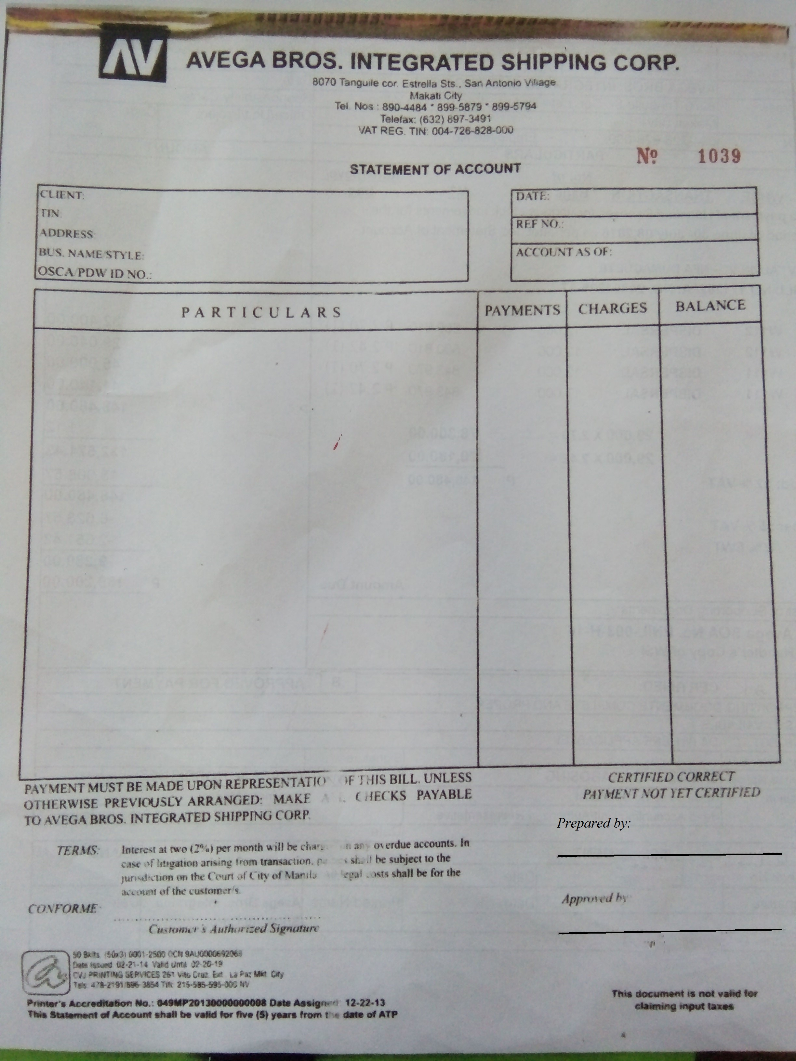

No. of Copies/color - 3 (white)

Explanation - This is prepared to bill customers for the services rendered.

Prepared by - Billing Staff

Approved by - Finance Manager

Conformed by - Customer

Distribution - Copy 1 - Customer’s Copy

Copy 2 - Accounting Department’s File Copy

Copy 3 - Billing Department’s Master File Copy

* 1. Official Receipt

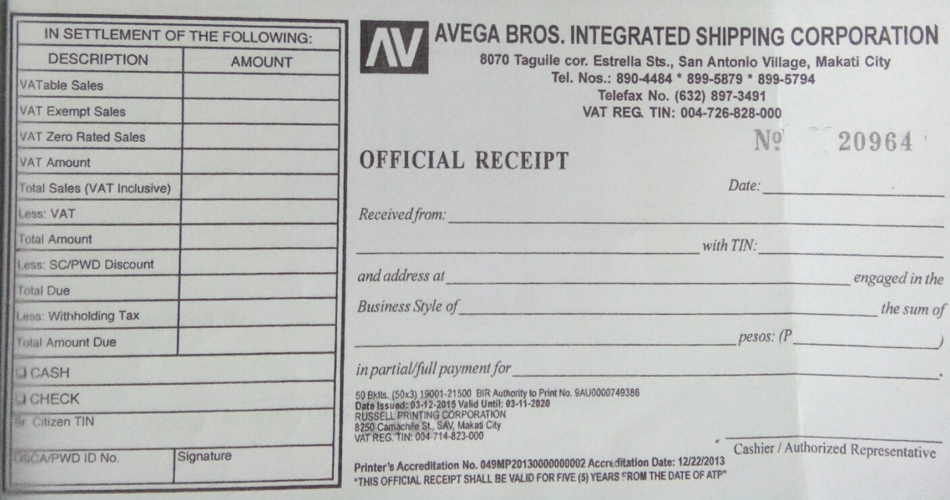

No. of Copies/color - 3 ( white / green / blue )

Signed by - Cashier

Distribution - White - Customer’s Copy

Green - Billing and Collection Department

Blue - Stub Copy

* 1. Pro-forma for Acknowledgment Receipt – Postdated Check (s)



No. of Copies/color - 3 (white)

Signed by - Cashier

Distribution - Copy 1 - Customer’s Copy

Copy 2 - Cashier

Copy 3 - Master File

* 1. Pro-forma for Daily Cash and Check (s) Received Report



­­­

No. of Copies/color - 3 (white)

Prepared by - Cashier

Verified by - Finance Manager

Distribution - Copy 1 - Cashier’s Master File

Copy 2 - Accounting Department

Copy 3 - Billing Staff

* 1. Pro-forma for Collections for Deposit Monitoring



No. of Copy - 1

Explanation - This is maintained by the cashier for the monitoring of collection to be deposited by the authorized collector or any representative to secure accountability of the asset (i.e. cash).

Maintained by - Cashier

Signed “Received by” - Authorized collector or any representative

Distribution - Handled and maintained by the Cashier

* 1. Pro-forma for Statement of Account Monitoring



* 1. Pro-forma for Postdated Checks Monitoring



* 1. Pro-forma for Cash Count Sheet



* 1. Pro-forma for Transmittal Report



1. EFFECTIVITY

This Policies and Procedures Manual shall take effect upon approval and shall supersede any memorandum/SOP inconsistent with this Policies and Procedures Manual. Any changes to the manual shall comply with the policies and procedures indicated in the process title *“Amendment of Manual”.*